The Price of the Influencer Lifestyle: Social Media Messages’ Effects on Mental Health

Ryan Thatcher
Department of Communication, Old Dominion University
COMM 595: Health Communication
Dr. Gary Beck
October 16th, 2024

It is often said that comparison is the thief of joy. With the rise of social media in recent years, many users find themselves in constant pursuit of validation, acceptance, and status amongst their peers. Crafting a desirable online identity has become a focal point for many people’s lives, whether it be for social or professional reasons. However, one must consider the factors that influence what is deemed ‘desirable’ and how the pressures of social media messages can take a toll on users’ mental health. As evidence suggests, social media messages heed an inherently negative impact on the mental health of users; constant comparison of self-identity to trending individuals and the messages they spread often leads to the development of various social and behavioral disorders. In a world that is growing ever more connected by social media and technology as a whole, it is important to diagnose the mental health issues posed by social media and its messages as early as possible, so that ample progress can be made to reduce the effects in the future. While there is a plethora of questions that still remain unanswered about the adverse effects of social media, the primary purpose of this review is to identify the documented effects of social media on mental health and examine how various kinds of messages can influence the development of these effects.
Before discussing the negative impacts of social media and its messages, it is important to emphasize that “…the quality rather than the quantity of social media use can determine whether the experience will enhance or deteriorate the user’s mental health” (Zsira et al., 2023, para. 2). With this in mind, one must note that social media’s emergence as a fundamental influence in everyday life comes not without its benefits. In a not-too-distant past, social media was the most common medium of communication in the world amidst the COVID-19 pandemic, which provided “mutual friendships, rewarding social interactions, and humor [that] also reduced stress…” (Zsila et al., 2023, para. 3). The sense of community that social media can provide users does serve its purpose of fostering human connection despite time and distance barriers, which allows anyone to find likeminded people or new communities of interest to be a part of. The scale of interconnectedness that social media provides can, in fact, “decrease the sense of stigmatization and increase belongingness and perceived emotional support” (Zsila et al., 2023, para. 3). Additionally, social media can be a platform for inspiring positive change by spreading information regarding social causes and philanthropic movements, many of which pertain to the research and treatment of mental health disorders. The community and platform for positive social and health messages and movements that social media provides users reinforces Zsila et al.’s statement about quality of social media usage being more influential than quantity. While unhealthy amounts of social media usage can have negative effects on the user’s mental health, recent events, such as the COVID-19 pandemic, have shown that social media messages can be a positive force during times of crisis.
Despite its fundamental benefits and increased importance during global hardship, social media still poses a myriad of issues regarding the impact it can have on the mental health of its users. Because social media’s constant evolution comes with new issues and increasing complications, “addressing the complex relationship between social media and mental health requires a multifaceted approach that goes beyond the actions of social media companies” (Minimitani, 2024, para. 6). However, proper examination of how users’ mental health is affected by social media requires examining the source: how social media companies influence the mental health of their users. One must consider that “69% of U.S. adults are social media users” and that “social media is especially popular among younger adults, as 86% of 18- to 29-year-olds are social media users” (Smith, 2017, para. 7). Taking the mass popularity of social media into consideration, it must be noted that social media companies have a wide spectrum of influence on society as a whole. However, social media companies often use algorithms and engagement to tailor each user’s experience to their unique interests. Social media platforms spread various content and messages based on what they think each user wants to see, as “humans are natural social learners. We are constantly scanning the environment to figure out what other people are doing and what we can learn from that” (Brady et al., 2023, para. 2). However, this can have a negative impact on the mental health of various users, depending on a variety of factors. Within these algorithms are various content pools linked by connector phrases, such as buzzwords or hashtags. Some of these content pools include content relating to depression, anxiety, trauma, and the like. Because users search for and interact with content they relate to, these algorithms created by social media companies to boost user engagement may push depressive or toxic content onto the feeds of users already struggling with mental health complications. This recurring presence of negative content, especially in bulk amounts per day, may be “associated with a higher risk of depression and anxiety” (Beyari, 2023, para. 3). However, a multifaceted approach to this issue requires recognizing that social media companies are not completely responsible for the actions of their users.
A natural aspect of human nature is to compare oneself to others. This comparison, in moderation, is necessary for setting standards for identity and success that people can use to gauge their progress and social status. With the rise of social media, “pressure to create the stereotype others want to see and also being as popular as others” (Karim et al., 2020, para. 4) has become a determinant factor in the behaviors of many individuals. With an inherent desire to be liked, people use social media “searching for validation on the internet that serves as a replacement for meaningful connection they might otherwise make in real life” (McLean Hospital, 2024, para. 10). Various terms relating to widespread anxieties, such as ‘FOMO’ (or fear of missing out), have become increasingly popular in recent years, as “if everyone else is using social media sites, and if someone doesn’t join in, there’s concern that they’ll miss jokes, connections, or invitations. Missing experiences can create anxiety and depression” (McLean Hospital, 2024, para. 11). The rise in prominence of these kinds of terms and messages shows that there are aspects of human nature that social media companies can’t control. However, this does not invalidate the fact that social media has an increasingly significant impact on its users’ mental health. Viewing the evolution of social media from a medical standpoint, “the U.S. has seen an increase in mental disorders overall, and among adolescents in particular” (Galea et al., 2024, para. 2). Considering that the evidence shows 86% of 18 to 29 year olds are social media users and that mental health disorders are becoming more prominent in adolescents, concern must be raised about the future of social media and the impact it can have on early development.
Because social media today plays a frontal role in the life of adolescents, teens, and young adults, one must examine the cognitive effects that social media can have on a developing brain. When social interaction and interpersonal relationships play such a crucial role in the development of a child’s identity as they grow, negative aspects of social media that even adults struggle with can make an overwhelming difference. Relating to the fear of missing out, “when people look online and see they’re excluded from an activity, it can affect thoughts and feelings, and can affect them physically” (McLean Hospital, 2024, para. 12). Considering that many children, teens, and even young adults haven’t fully developed their social skills and moral compass, social exclusion and online harassment have more of an impact on their mental health and may normalize poor social behaviors. Additionally, access to any kind of content may be harmful for the developing mind, as influencers and messages that promote unhealthy lifestyles may act as poor role models to children and teens that may find their page. This side of social media, when paired with a developing mind, may “increase risk of addiction and cyberbullying involvement” (Zsila et al., 2023, para. 4). With platforms evolving exponentially every year, many call for more stringent terms of service and parental controls that would set stricter regulations for ‘toxic’ influencers and monitor the child’s activity on the platform. This is mainly because “some behaviors—even if rare—are explicitly harmful and emerge from social media exposure by adolescents. These behaviors, including cyber-stalking and harassment, are well documented and most troubling because of the difficulty that social media has in policing these behaviors—or even in providing opportunities for adolescents who experience them to report these behaviors or shield themselves from them” (Galea et al., 2024, para. 8). When an adolescent spends most of their time learning from those around them, those with status on social media become figures in the adolescent’s life and impact their identity thus forth. With the current structure of social media today, “technologies aiding young people in comparing social statuses present a risk to their mental wellbeing. Some turn to social media to increase followers and gain a sense of gratification to compensate for their emotional and psychological challenges. This leads them further down the path of a graver depression” (Beyari, 2023, para. 8).
This evidence raises further questions about what can be done to combat negative mental health derived from social media usage. Some suggest that “policymakers could consider implementing stricter rules and guidelines for social media companies to follow, such as requiring them to prioritize user well-being and mental health over engagement and profits” (Minamitani, 2024, para. 6). Such guidelines would include “mandating regular mental health impact assessments, providing resources for mental health support, and implementing stricter content moderation policies to reduce the spread of harmful and toxic content” (Minamitani, 2024, para. 6). However, there are some issues with taking legal action, mainly stemming from existing legislation. According to Section 230 of the Communications Decency Act of 1996, which “provides immunity to online platforms from civil liability based on third-party content and for the removal of content in certain circumstances” (DOJ, para. 2), social media companies are not directly responsible for the content users post, as well as how users interact with said content. This creates a difficult polarization in perspective on the topic, as “strong opposition is expected from users and companies on human rights grounds, including violations of freedom of expression” (Minamitani, 2024, para. 6). On one side, social media can be detrimental for mental health and something must be done about it. On the other side, the prominence of social media and legal obstacles make it difficult for significant change to be made.
According to Karim et al., the problems posed by social media may also have some relation to the Displaced Behavior Theory, which states “people who spend more time in sedentary behaviors such as social media use have less time for face-to-face social interaction, both of which have been proven to be protective against mental disorders” (Karim et al., 2020, para. 4). This evidence essentially states that social media use is a sedentary – or inactive -- behavior, “which, if in excess, raises the risk of health problems” (Karim et al., 2020, para. 4). Sedentary behaviors, which involve any seated or resting activity, have numerous effects on humans if done too frequently. However, one effect to underline is that sedentary behaviors “were positively correlated with depression risks” (Park et al., 2020, para. 24). When combining the effects of a sedentary lifestyle with the social anxieties and addictive nature of social media, one can experience a significant toll on their mental health. With social media addiction becoming a frequent topic of discussion in the health industry, one must consider the added downsides that come with the sedentary nature of social media usage and how it may only further fuel addiction and depressive symptoms. Similar to the ouroboros, a sedentary lifestyle can quickly evolve into a social media addiction, whereas a social media addiction can also lead to a sedentary lifestyle. The recurring issue is that “sedentary behaviors may increase the risk for depression by blocking direct communication and lowering social interactions, or by reducing the available time to engage in physical activities that help to prevent and treat depression” (Park et al., 2020, para. 24). When addiction to social media becomes more severe, it requires an individual to spend more time on the platform, leading to more sedentary behaviors. Often times, as mental health declines, people tend to look to social media more frequently as an escape or for validation, which tends to cause a reliance on social media for self-esteem, rather than finding it through offline accomplishment. This can become a very dangerous downward spiral if not managed properly, which remains an issue for many.
With social media playing such a pivotal role in daily interactions and behaviors, identifying and diagnosing both the positive and negative effects it can have on mental health is incredibly important for making a step in the right direction. Reducing the mental health risks of social media while capitalizing on its benefits requires a more structured, long-term plan if success is to be achieved. However, as stated earlier, there are a variety of roadblocks that currently prevent effective changes from being made, whether it be socially, legally, or morally. This leads to the proposed research question: what can be done to reduce the negative effects of social media and its messages? Considering the current circumstances, “it is crucial to organize the evidence to date and explain convincingly that the restriction is urgently needed for public health reasons and that there are no other measures that could be taken” (Minamitani, 2024, para. 6). Identifying methods and future plans that may aid in reducing the negative impacts of social media is the main focus of the upcoming proposal, aiming to highlight the best possible courses of action and how they can be carried out.
Using the warrant to understand the various effects of social media on mental health, a proposal can now be issued with the purpose of improving health outcomes stemming from social media usage. In order to create a proper intervention, researchers must consider the most at-risk demographics and the best methods for reaching them. It is crucial to identify these factors before attempting to stage an intervention, as utilizing proper methods based on the target demographic can maximize the intervention’s effectiveness on the individuals. Going forward, this proposal will sample the most at-risk demographic and tailor the methods and procedures for the intervention using the sample demographic’s behaviors and tendencies. Furthermore, the process of data collection and an evaluation of this study will be included to determine the effectiveness of the intervention.
With billions of users across various social media platforms, there is a plethora of demographics and groups that use social media. This makes identifying the most at-risk group difficult, as social media can have different effects on users based on age, location, background, and other identity-based information. However, “initial studies from 2015 found that nearly half of a sample of psychiatric patients were social media users, with greater use among younger individuals” (Naslund et al., 2021, para. 5). Taking this information into consideration, the sample of this intervention should be the demographic most active on social media: those between 18 and 25 years of age. To ensure more accurate results and achieve at least a medium effect size, this intervention will analyze two groups of 50 to 100 individuals (or 100-200 total) that fit the age range. Both sample groups, which will be an intervention group and a control group respectively, should be formed with individuals from differing backgrounds, such as college students or young adults in the workforce. By creating diverse sample groups that fall within the given age range, different kinds of feedback can be documented and analyzed to stratify the data and understand the results more thoroughly.
The procedure will focus on staging an intervention by using persuasive media and training to connect with the sample groups. However, as previously mentioned, the intervention will only be administered to one group to accentuate the difference in outcomes. The first group, the intervention group, will be shown a video (see Appendix A) that underlines the negative effects of social media usage, using sound evidence and prior research to support the claims. The video will also include multiple strategies for healthy social media usage, including techniques for maintaining a healthy content feed, establishing time limits for individual apps, and emphasizing the importance of face-to-face interaction. The intervention group will then participate in an in-person, mediated workshop that helps the individuals fine-tune and practice positive social media habits based on their own usage. As for the control group, these individuals will not be shown the same video or have the opportunity to partake in the workshop, but rather be given baseline mental health advice that does not pertain to social media usage. This contrast of methods between the intervention group and control group aims to highlight the greater impact of this intervention when compared to standard procedures.
In order to see and understand the effectiveness of this intervention, there will be a series of assessments prior to the procedure that will quantify each individual’s mental state on three levels. These same tools will be reissued to both sample groups in a post-procedure assessment in hopes of collecting data that shows the intervention’s positive impact on the groups. The ideal tools to be used for this study are the PHQ-9 (Patient Health Questionnaire-9) (see Appendix B1), the Rosenberg Self-Esteem Scale (see Appendix B3), and the GAD-7 (Generalized Anxiety Disorder-7) (see Appendix B2). The PHQ-9 and the GAD-7 will provide quantified data regarding depressive and anxious behaviors that individuals may have prior to the intervention, whereas the Rosenberg Self-Esteem Scale will be used to quantify each participating individual’s sense of self-worth. After administering these assessments and completing the intervention, a post-assessment utilizing the same tests should be given to both sample groups about one to two months later to show the change in individuals’ mental states. Additionally, social media usage and screen time data – collected by the devices that individuals use to access social media – should be collected before and after the intervention to show differences in usage patterns.
Once all data is collected, the next step is to compare the differences in data of both the intervention group and control group, respectively. This data can be compared on the individual level for a broader scope of overall change but can also be consolidated into group averages to generalize the results and impact of the intervention. While analyzing this data, trends and patterns should be studied to support the hypothesized relation between social media usage and mental health. Supporting evidence for this claim should prove a “statistically significant relationship between social media use and mental health” (Nazari et al., 2023, para. 29), as well as a notable impact of the workshop. Positive results of workshop should follow a certain pattern; after the intervention group employs the workshop strategies over the course of one to two months, the results of the PHQ-9, GAD-7, and Rosenberg Self-Esteem Scale should improve. Conversely, the results of the control group should remain unchanged after the given time frame, though it is possible that the post-assessment data could reflect a decline in mental health as a result of not having viewed the video or participated in the workshop.
There are a handful of complications pertaining to this study. The main issue is that the tests given before and after the workshop may not be completely accurate, as all of the assessments are self-reported. Results of these tests are determined by the honesty and perspective of the participant, which can be affected by several factors, such as emotional intelligence or the participant’s tolerance for self-disclosure. Emotional intelligence is a crucial aspect of this study, defined as “the ability to monitor one's own and other people's emotions, to discriminate between different emotions and label them appropriately, and to use emotional information to guide thinking and behavior” (Srivastava, 2013, para. 3). For example, an individual who is willing to answer the questions as truthfully as possible but lacks the emotional intelligence to understand and convey their mental state may produce inaccurate results, as communicating feelings they themselves fail to understand often leads to hesitant or unconfident responses. Similarly, another individual may have the emotional intelligence to understand their emotions and monitor their mental health but lack the willingness to communicate these feelings. Often, those who possess high emotional intelligence while practicing low self-disclosure respond dishonestly or may even refuse to respond at all. This can create further complications that make analyzing the information and taking the results at face value difficult.
Another potential shortcoming of this study is that the effects of the workshop are completely determinant on the sample group’s willingness to practice and apply the techniques provided. Unfortunately, there is a higher chance than would be desired that the individuals of the intervention group partake in the workshop and apply little to none of the strategies taught during the one-to-two-month period. If the majority of the group decides not to apply any of the techniques, the results may be stagnant or show insignificant change. While this workshop has the potential to make a positive impact on the social media usage and mental health of the intervention group, the results are ultimately determined by each individual’s application of the techniques and willingness to hold themselves accountable during the post-workshop time frame. The fact that the results of this study are completely based on the honesty, emotional intelligence, and willingness to apply the strategies poses a handful of potential problems for conducting accurate research.
However, if the results prove this intervention to be successful, the implications of this research could be used on a larger level to raise awareness and bolster research regarding the topic. Because the age range for the sample is 18 to 25, the results of this research can be applied to educational settings (mainly high schools and universities), mental institutions, professional spaces, and youth development programs. The low cost of the video and workshop allows for various settings and institutions to implement the intervention without the concern of investing a lot financially. The success of this intervention also supports other health communication theories, such as the Extended Parallel Process Model, which “describes the behavioral change process as the relationship between the fear of a health message or health risk situation, and the individual’s sense of efficacy in coping strategies” (Yoon et al., 2022, para. 6). By coupling a sense of health-related fear with solutions and strategies for combatting this fear, individuals are more inclined to make a change in behavior, which is what is hoped to be accomplished through this intervention.
Furthermore, producing positive results can add valuable insight into media effects, providing numerical research results that can be used to understand the bond between social media and mental health. This kind of research can have an impact on numerous other aspects of society, such as policy or culture. The results have the potential to influence policymakers into passing regulations that social media platforms must adhere to, most of which could further promote healthy social media usage habits for users. Similarly, regulations for workplace usage, such as integrating digital wellness modes or required usage and mental health meetings, could be implemented in professional settings to help employees maintain healthy behaviors. From a cultural standpoint, the implications of this study would aim to emphasize the importance of interpersonal communication over digital or virtual communication, as interpersonal interaction “plays a pivotal role in the shaping of individual’s well-being as well as their psychological resilience” (Shahi et al., 2024, para. 4). Considering the sample group, this study has the potential to reform the way that younger generations interact with social media in the future. By educating younger generations on this topic while social media is still a growing concept, significant cultural changes can be made to reduce the effects of social media on the mental health of future generations. This proposal has a wide range of potential outcomes that can reinforce existing communication theories, influence policy and culture, and have a lasting impact on society as a whole.
Social media is becoming an increasingly prominent aspect of daily life, so understanding the harmful impacts it could have on mental health and employing successful intervention strategies is essential for navigating the future of social media as it relates to health communication. By educating young adults about the effects of social media on mental health, their generations – as well as the ones that follow them – will be able to properly evaluate their behaviors on social media while implementing and practicing strategies for improving mental health and maintaining healthy social media usage. As previously stated, this intervention has a handful of complications and potential shortcomings, as accountability, effective application, emotional intelligence, and self-disclosure all have notable impacts on the data and results of the intervention. However, if conducted as effectively as possible, this intervention has the potential to influence the actions of individuals on a large scale, providing foundation for a cultural change in attitude towards social media. Such changes would positively impact the way policymakers, educational institutions, and other public entities approach matters of social media and mental health, most likely in a manner that promotes healthy online habits and emphasizes the importance of monitoring one’s mental health. With sufficient research and appropriate action, the harmful effects of social media on the mental health of its users can be held to a minimum, which is important to achieve as social media grows. To conclude, this proposal aims to conduct a successful intervention using persuasive media, engaging workshops, and established health assessments to identify and reduce the negative impacts social media has on mental health, as well as raise awareness and educate younger generations about the risks and benefits of social media usage.

REFERENCES
Beyari, H. (2023, January 29). The relationship between social media and the increase in mental health problems. International journal of environmental research and public health. https://pmc.ncbi.nlm.nih.gov/articles/PMC9915628/
Brady, W. (2023, August 29). Social-media algorithms have hijacked “social learning.” Kellogg Insight. https://insight.kellogg.northwestern.edu/article/social-media-algorithms-have-hijacked-social-learning
Galea, S., & Buckley, G. J. (2024, February 27). Social Media and Adolescent Mental Health: A Consensus Report of the National Academies of Sciences, Engineering, and medicine. OUP Academic. https://academic.oup.com/pnasnexus/article/3/2/pgae037/7614669
Karim, F., Oyewande, A. A., Abdalla, L. F., Chaudhry Ehsanullah, R., & Khan, S. (2020, June 15). Social media use and its connection to Mental Health: A Systematic Review. Cureus. https://pmc.ncbi.nlm.nih.gov/articles/PMC7364393/
Mass General Brigham - McLean. (n.d.). Here’s how social media affects your mental health. McLean Hospital. https://www.mcleanhospital.org/essential/it-or-not-social-medias-affecting-your-mental-health
Naslund, J. A., Bondre, A., Torous, J., & Aschbrenner, K. A. (2020, September). Social Media and Mental Health: Benefits, risks, and opportunities for research and Practice. Journal of technology in behavioral science. https://pmc.ncbi.nlm.nih.gov/articles/PMC7785056/
Nazari, A., Hosseinnia, M., Torkian, S., & Garmaroudi, G. (2023a, June 22). Social Media and Mental Health in students: A cross-sectional study during the COVID-19 pandemic - BMC psychiatry. BioMed Central. https://bmcpsychiatry.biomedcentral.com/articles/10.1186/s12888-023-04859-w
Minamitani, K. (2024, May 20). Social Media Addiction and Mental Health: The growing concern for youth well-being. Stanford Law School. https://law.stanford.edu/2024/05/20/social-media-addiction-and-mental-health-the-growing-concern-for-youth-well-being/
Park, J. H., Moon, J. H., Kim, H. J., Kong, M. H., & Oh, Y. H. (2020, November). Sedentary lifestyle: Overview of updated evidence of potential health risks. Korean journal of family medicine. https://pmc.ncbi.nlm.nih.gov/articles/PMC7700832/#sec7
Shahi, U., & sharma, lokesh. (2024). Interpersonal Communication and Mental Health: An Impact Study of Interpersonal Communication Skills on Mental Health of Youth. https://doi.org/10.2139/ssrn.4874014
Smith, A. (2017, January 12). Record shares of Americans now own smartphones, have Home Broadband. Pew Research Center. https://www.pewresearch.org/short-reads/2017/01/12/evolution-of-technology/
Srivastava, K. (2013, July). Emotional intelligence and organizational effectiveness. Industrial psychiatry journal. https://pmc.ncbi.nlm.nih.gov/articles/PMC4085815/
United States Department of Justice. (2023, May 8). Department of Justice’s review of Section 230 of the communications decency act of 1996. Office of the Attorney General. https://www.justice.gov/archives/ag/department-justice-s-review-section-230-communications-decency-act-1996
Yoon, H., You, M., & Shon, C. (2022, March 8). An application of the extended parallel process model to protective behaviors against COVID-19 in South Korea. PloS one. https://pmc.ncbi.nlm.nih.gov/articles/PMC8903272/
Zsila, A., & Reyes, M. E. S. (2023, July 6). Pros & Cons: Impacts of social media on mental health - BMC psychology. BMC Psychology. https://bmcpsychology.biomedcentral.com/articles/10.1186/s40359-023-01243-x

Appendix A
Educational Video
Figure A1
Educational Video – Huberman Lab
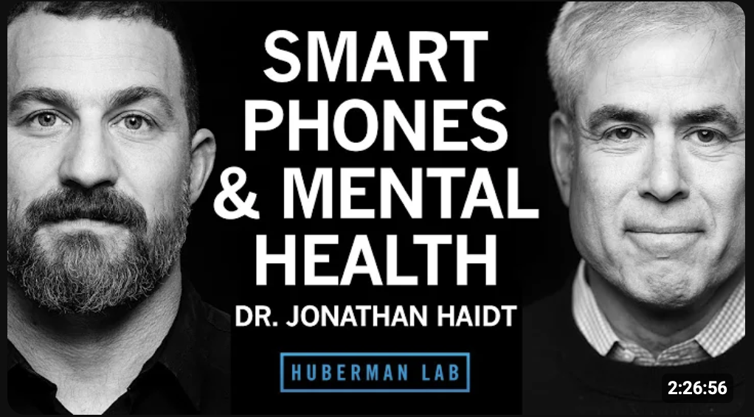
Note: An educational video by Dr. Jonathan Haidt from Huberman Lab detailing the effects of smartphones and social media on mental health.
Appendix B
Assessments
Figure B1
Patient Health Questionnaire-9 (PHQ-9)
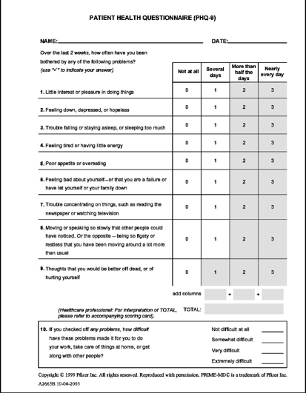
Figure B2
General Anxiety Disorder-7 (GAD-7)
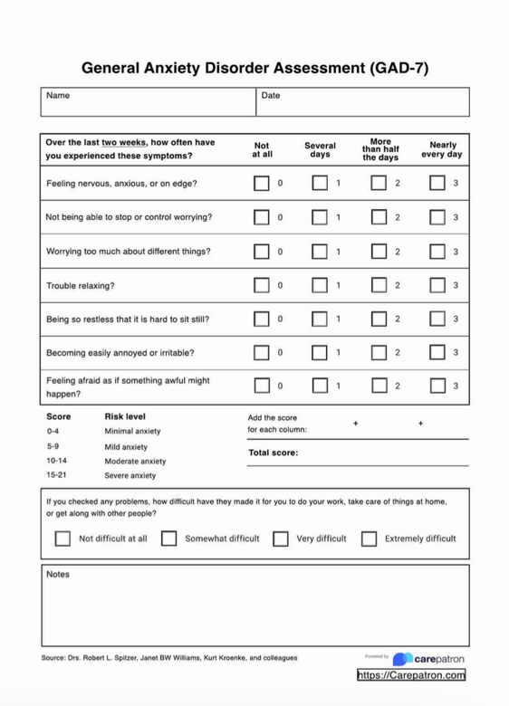

Figure B3
Rosenberg’s Self-Esteem Scale
